Kuang Ming Saint Tao Temple

Issue 4 August 2003

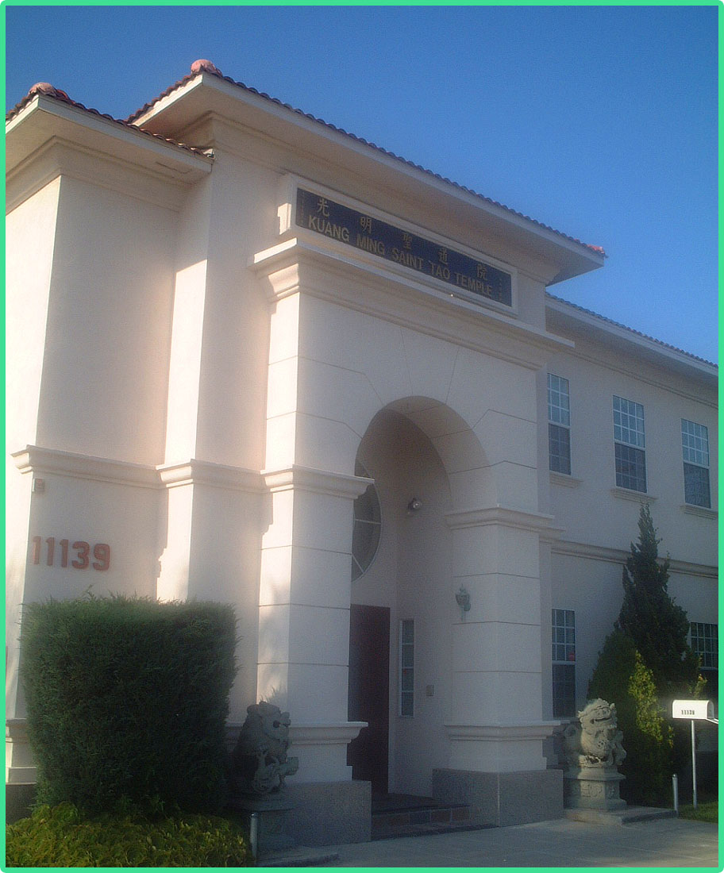

From the Editor:
Thanks to the grace of Heaven and the virtue of the Masters, we finally get to see a new issue of SOS in 2003! It’s been a while. Sorry for the long wait.
I’d like to thank the unsung heroes, who helped me to deliver this issue to you, for their kindness and patience. This issue would Not be completed without them.
Some changes have taken place in this new issue. I hope you’ll like the newly improved SOS. Also, don’t forget to do the survey at the end of this issue. Your participation is greatly appreciated.
In addition, if you have any thought or experience that you would like to share with us, don’t be shy!! For more information, please contact Angel Huang (SuikaShen@aol.com). This e-mail address is for anything that is SOS-related and will be checked once a week.
By the way, do you know you could also enjoy reading SOS online? You could do so by logging onto http://www.fecdkm.org/english/index.html .
While you’re there, don’t forget to check around the website.
Now, let’s enjoy this brand-new issue of SOS!
Inside

Explanations of The Answers to the Truth
       3

Journey
Voyage to China 2002: Some Reflections (II)
       5

Sharing
The Days after I Received Tao
      7

Upcoming Events
2003 Monthly English Tao Class Schedule
      8

Activities
A Wish from the Heart
      9

Activities
Collage of Activity Pictures
      11

A Vegetarian’s Kitchen
      12

Message Board
      13

Issue 4 August 2003

Kuang Ming Saint Tao Temple

11139 E. Lower Azusa Rd.
El Monte, CA 91731
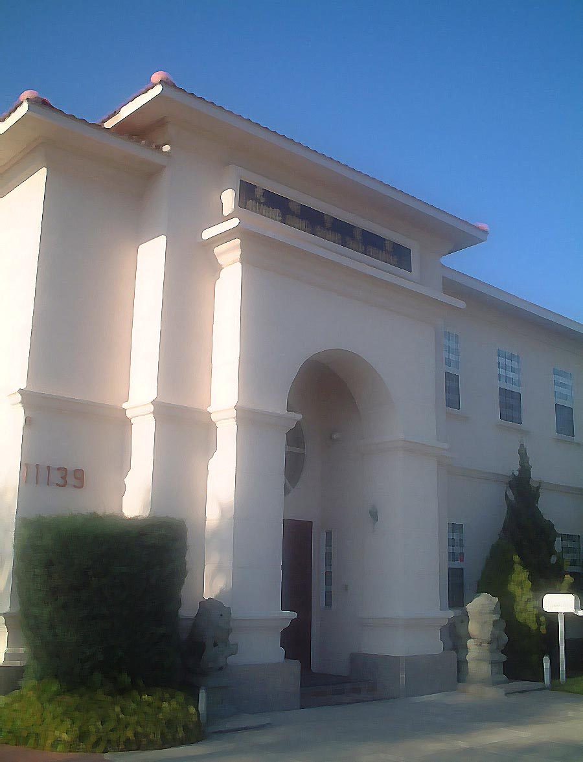

Explanations of *

Holy Teacher, Ji-Gong Living Buddha

How can one accumulate merits after receiving Tao?

The constant maintenance of the True Nature in one’s heart is the virtuous nature. When the virtuous nature is manifested in one’s daily practice, it is the true ethics and morality. If one has Tao but lacks virtues, he is a devil. Confucius said: “Only with perfect virtues can a person attain Tao.” Virtue means to attain Tao. To accumulate merits is the same as establishing one’s virtues.

To establish one’s virtues, one should help the needy, vow to relieve disasters and bring salvation, follow the teachings of the five religions, and carry the teachings into practices to the fullest extent. Merits are accumulated through donating to print Sutras and Scriptures, establishing God’s Altars, exhorting and touching the sinful, spreading God’s truth in the land of non-believers, advocating Tao and virtues, stimulating the wisdom of others, and introducing and supporting others so they can attain Tao. When the external merits are fulfilled, the internal merits will be facilitated.

In terms of social work, one can donate his own wealth to help the needy and to provide relief to disasters, or to raise funds if the need is too great for a single person to fulfill. In all cases, we must adapt and adjust our approaches according to the time, the place, the people, and the task. We should persuade parents to care for children, children to fulfill filial devotion, siblings to have friendship and respect for each other, spouses to live in harmony, friends to trust each other and be trustworthy, government officials to be loyal and fair, the sinful to repent, and the ordinary to be Sages. True merits are accumulated as long as one does not intent to build reputations and expect praises, nor deploy harsh words and attitudes. If one intends to build reputations or receive praises, he accumulated no merit despite of the good deeds. He will only be rewarded in his next life. If one exhorts others in a harsh or infuriated tone, then he is not a practitioner of Tao**.

Even though Tao is true, why are there so many
non-believers?

Whether a person will believe in Tao when he hears it depends on the colletive merits of his ancestors and his own foundation in wisdom. If one has faith in God, he will follow Tao earnestly. Those who do not have faith will not practice Tao even if they are coerced into doing so. It is difficult for those who do not have faith to receive Tao. Only the family with collective merits from their ancestors will give birth to children who will receive Tao and practice Tao.

This can be illustrated by the following parable. There is a mountain rich in gold ore. The sovereignty is willing to grant mining privileges to anyone. The commoners, who lack wisdom, think that gold cannot be found in stones and take no action to this opportunity. The wise ones act immediately and file claims. Soon, the output of the mines rises to a thousand ounces of gold a day. All the wise ones become rich instantly. By the time the commoners realize that there is indeed gold in the ore, they rush to file claims. By then, it is already too late, for the wise ones have claimed all the mines. As much as the commoners regret, there is nothing they can do now. This parable illustrates the saying: “The blessed will be born along with the Saints so he can learn Tao. The unblessed will be born when Tao is not available.”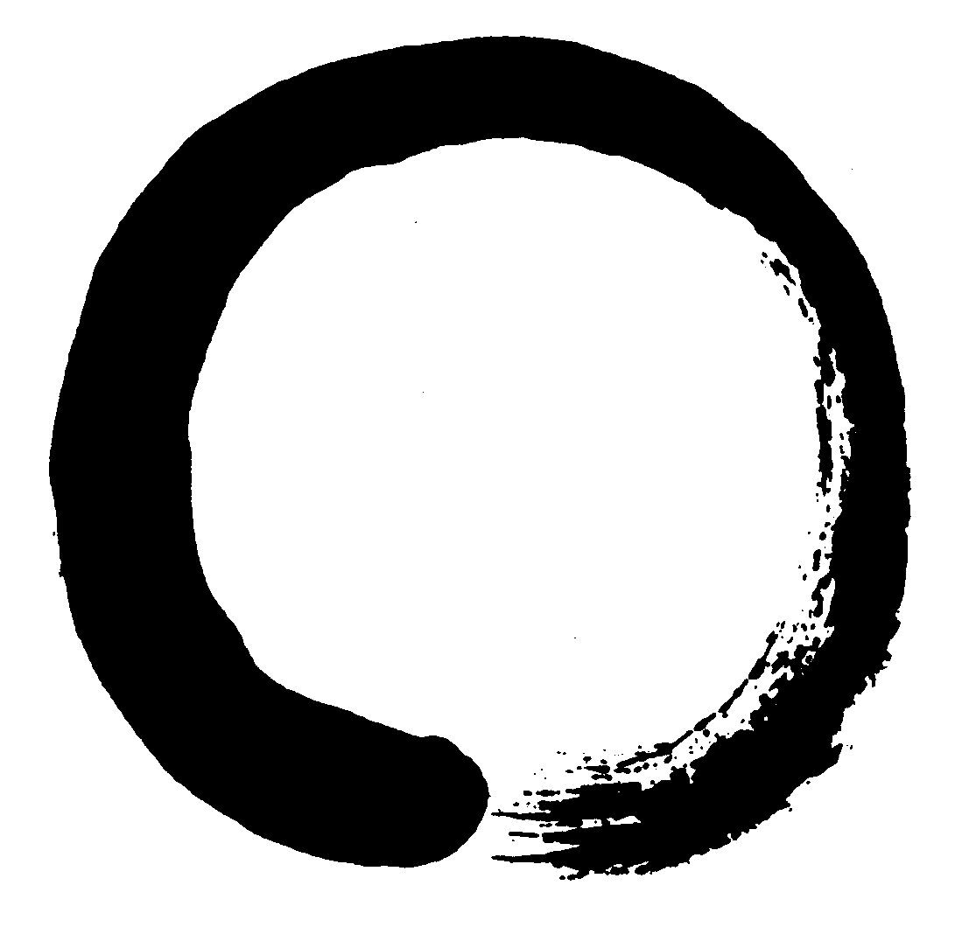
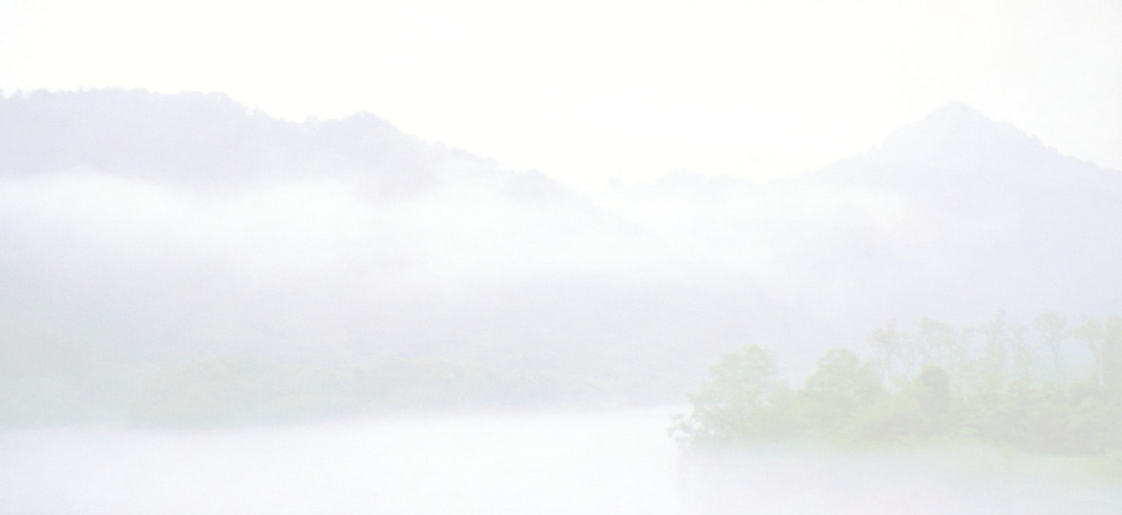
DEVOTE
Do your best to take your duty and set good examples
Enlighten others and be a good disciple
Volunteer to practice Tao and make yourself supple
Orient yourself without scruple
Take more time and help people
Enter the greatest Tao way and invite others to come to the temple
By Holy Teacher

Notes from the Editor
* The above Q and A’s are taken from the book, Explanations of The Answers to the Truth (Xing Li Ti Shi). The original Chinese version is by Holy Teacher, Ji-Gong Living Buddha. It contains 90 Q and A’s. The English version is translated by the translators at Zhong-Hua Public Temple.
** Tao cultivator is referred as practitioner of Tao in this book.

 (Part II)

Thomas E. Maher
“This is all about power, wealth and sex.” Those words were blurted out soberly, spontaneously and with feeling by one of our fellow travelers as we were touring China’s ancient capital of Xian, our next stop after leaving Beijing. He was of Chinese ancestry, so I didn’t regard his outburst as innately hostile to China or ethnically prejudicial. In fact, I think he had a point because, by now, we had become quite well acquainted with the use and abuse of imperial power, its appropriation of treasure unto itself, its virtual imprisonment of young women in the emperor’s service as concubines, and the physical and emotional ruin inflicted upon young men pressed into his employ as eunuchs. The Ming tombs in Beijing had been an apt illustration. The emperor could not let go of his possessions even at death because to do so would acknowledge his mortality. The concubines and eunuchs had to die and be buried with him so that his accoutrements of privilege and power could be preserved to support his hope for life in the hereafter.
Xian, China’s ancient capital! Have I been transported in a time capsule back to the second century BCE? Before the birth of Jesus Christ? Am I really standing just a few paces away from the life-sized terra cotta foot soldiers and cavalry that China’s first emperor, Qin Shi-huang, had made to protect himself from his enemies in the after-life? It seemed surreal, because these are not reproductions. These are the originals, more than two thousand years old and perfectly preserved under cover of a huge stadium constructed after their discovery in 1974. Only their color had disappeared. Unfortunately, some had been maliciously damaged or destroyed by rebels when they ransacked the tombs not long after the emperor’s death.
I had seen pictures of these remarkable statues before in various periodicals but had never thought that I would someday view them with my own eyes. They are so well formed and perfectly preserved. Only the colors have been worn away by time. The statues are so life-like in appearance that they seem about to move at any moment. But they never do. They just stand there motionless in the silence of death. As we left, we passed by the emperor’s tomb itself. It seemed less than a kilometer away and, still unexcavated, was covered by a mound of earth and tall, green grass. I wondered what secrets the recovery teams will unearth when the day finally arrives and what further we will learn about that first emperor, whose brutality and cruelty are legendary, but who unified China and began the building of the Great Wall.

We next visited the ancient Wild Goose Pagoda, Xian’s primary symbol. It was built in 674 CE, and in it are housed the Buddhist sutras that were brought to China from India. Its surroundings are beautiful, and one wanted to linger there. We then headed for the Huaqing Hot Springs, where the

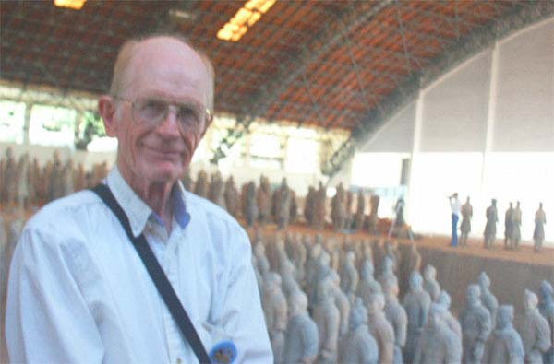

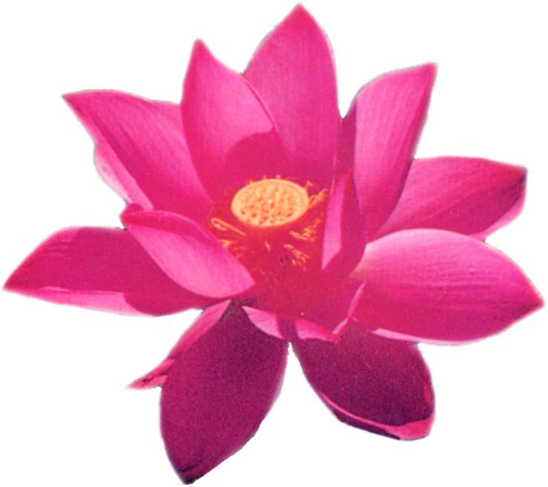

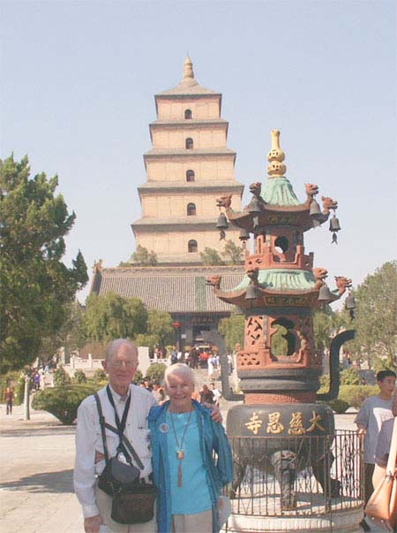
emperor frolicked with his concubines. In the middle of a large pond (no doubt of subterranean origin), there was a large white, life-sized, marble statue of a beautiful, semi-nude woman whom everyone wanted to take a picture of! Judging from its condition, it seemed to be of recent origin. As I viewed the statue and its surroundings, I could not help but recall the summer palace of the Ming emperors in Beijing, which we had just visited, and the long, covered walk-way where their concubines strolled in their exquisite finery. It also reminded me of the original statue of the Greek Goddess, Venus De Milo, which I had seen in the Louvre when I was in Paris years ago.

The ancient buildings that comprised the Hot Springs were picturesque and well preserved, as were the baths inside them. Of ancient origin, they were patronized at least as far back as the Zhou dynasty because of their mineral content. Green mountains surrounded the area, adding to its overall beauty. Our guide advised us that it was on the side of one of these mountains that General Chiang Kaishek was captured and forced into an alliance with Zhang Xueliang, another nationalist war lord, who, unlike Chiang Kaishek, believed it more important to resist the Japanese than pursue Mao Zedong’s Communist militants.
Night had now fallen, and it was time for an evening performance. It was entitled the “Tang Dynasty Dance Show.” The performers were outstanding, and the colorful, vivid costumes and stage settings overwhelmed one’s eyes.
We had spent two days in Xian and left very early on the morning of the third day for Shanghai by plane. As I previously mentioned, I had been to Shanghai two years before on a research project. At that time, more than eighty percent of China’s population lived below the poverty level, and many people were fleeing from the agricultural areas to the cities seeking a better life. Not finding it, large numbers turned to crime to eke out a livelihood. While crime and poverty are still major problems in China, particularly in its vast Western area, I was astonished by the progress made in Shanghai in two and a half short years. There was new construction everywhere and, of course, jobs to go along with it. Although other areas we saw were quite depressed, there seemed to be hope on the horizon for China’s destitute.
Of course, we were not to leave Shanghai without seeing the heart of its famous “old town” center. When one strolls through the maze of its quaint, narrow streets, one is suddenly transported back to an earlier, more traditional China, with its characteristic architecture. I fully expected to run into Richard Holden and Suzy Wong (from the old movie of the same name) threading their way though throngs of pedestrians!

From Shanghai, we went to Guilin, whose distinctive beauty inspired China’s poets and artists of old, but that episode is scheduled for the next edition of S.O.S. (To be continued)
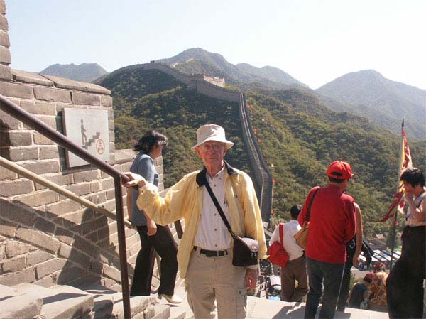

Aaron Lin
To me, Tao is still obscure and abstract. If someone were to ask me what Tao is, I would answer the only thing I know, “Tao is everything. Tao is present before the beginning of the universe. Tao is within you and me.” But, does that answer the question completely? I doubt it. However, if one were to ask the differences between before and after I received Tao, I would reply sincerely and firmly: “Oh yeah, you bet.”
Before I received Tao, I had a very ill temper. I would get upset and angry very easily. When I got angry, not only I would yell and shout, I would also physically confront the individual who triggered my temper. However, after I have received Tao and continuously attended the classes at the temple, I began to feel responsible for my own actions and speeches. I feel that our Holy Teachers (Patriarch and Matriarch) are “up” there watching me. I feel as if they were my godparents. When I was thirteen, I was sent to Canada as an international student; I would usually do and say whatever I wished. No one was there to lecture or educate me. After I received Tao, I realize Holy Teachers are watching over me constantly, I feel that I have to behave better; otherwise, they would be disappointed. Now, whenever I get angry over something, I would just “inhale” and “exhale” and ask myself “why am I angry? Is it worth it?” By doing so, the hatred and anger would pretty much be worn off. Of course, this would not work every time, but the frequency of getting angry has been dramatically decreased compared to the past.
Before I received Tao, what my parents meant to me were pretty much just my source of income. In another words, they were my unlimited balance ATM (auto teller machine). My attitude was like: “wire me the money and I’ll be just fine,” or “I do not need your love, but I certainly need your green bills,” or even more straight forward “Just give me the money and leave me alone.” I barely called them in Taiwan and if I did, I would call to ask for more money. If they tried to call me, sometimes it would take days for them to reach me. Even if they did reach me, I would sound annoyed and wanted to hang up as quickly as possible. Occasionally, my mom would cry because I treated her “really” badly.
However, after I received Tao, everything changed. The stories I heard from the Tao classes and Tao seminars and from some incidents happened in my life, I have come to a realization of how dumb I had been. Now, I would call my parents occasionally. Instead of asking for money, I would ask how they are doing without any obligation and purpose--“Just call to say wassup!” Before I received Tao, my mom would cry because of the way I treated her. After I received Tao, my mom, however, would still cry because I have finally turned into a man of whom she is proud. Every now and then, I would call my parents to share the stories I heard in the temple.
If I say I changed this much it is because I received Tao, it would definitely sound impossible and impractical. I felt this when I received Tao--our Holy Teachers granted me the chance of getting to know the wonderful people in the temple, and, because of those people, I came to realize my foolishness. If it weren’t for my introducer Ally, none of these would happen. When she first tried to convince me to come to the temple, I said “yeah right, not in this lifetime.” However, she did not

However,

give up. After months of struggle, I was finally persuaded by her persistence. I decided to give it a shot. I came, I ate and I listened. It was not as bad as I imagined (though I did not understand the lectures 100%). Besides, the food was delicious and most important of all--it was “free.”
Therefore, I have to thank my introducer for her patience and persistence that lead me to a brighter path in my life. Then, there is my guarantor. I could still remember the day on which I decided to receive Tao; my guarantor “cried” even though she did not know me that well. Her tears showed me that she was really happy for me. From then on, I felt that I have to be a better person, not just for myself but also for my introducer because she “guaranteed” that I am a good person. If I don’t, my mom, Holy Teachers, my introducer, my guarantor, and myself would suffer. Then, there are the lecturers from the temple who are my living dictionary. I always think “if there is a question, ask them for the solution.” They always have the patience to answer my questions even if the question itself is quite nonsense and weird. Nonetheless, they never seem to be bothered. They always encourage me, such as, “you can do it.”
Thank you for your patience and for everything. But, please be prepared because I will have more harder, and more weird questions waiting for you to solve. I would like to also thank lecturer Amy and Lecturer Debbie for their caring. When I feel sick, they would give me massages, and give me free food. They are also like my godmothers. And, of course, everybody else in the temple. If it weren’t for everybody here, this temple would not be a heart-warming and love-giving temple anymore.
Many people say it is rare for a teenager like me to come to temple regularly like this especially when it is party time on Saturday. However, I would say it is because the temple gives me a sense of being home, the home that I haven’t gone back to for years, the home that gives me a sense of comfort and security. This is my home, my home in the U.S.

Date | 1st Session*: 2:30-3:30 PM 2nd Session*: 3:40-4:30 PM | Speaker
8/2 | 1. Ceremony of Receiving Tao  2. A Brief Introduction to Yi-Guan Dao (I-Kuan Tao) | Benn Koai  Rev. S-M. Hwang
9/6 | 1. Holy Teacher—Ji-Gong Living Buddha  2. The Buddha & Jesus: Different Messenger, Same  Message? | Wendy Cheng  Thomas Maher
10/4 | 1. Open Discussion: Ninety Questions Concerning the  Great Tao  2. Cause and Effect | All  Jang Hwang
11/1 | 1. Meeting and Preparation for Christmas Party  2. The Path to Enlightenment | Phil Smith  Arnold Wang
12/6  * 1st Session: Open to those who completed Tao Seminar & made vows.  2nd Session: Open to all. | 1. Feedback and Encouragement  2. Christmas Party | Rev. J-R. Kuo  All

Rev. Kuo’s Speech at the Christmas Party

Rev. Winston (W-F.) Kuo
It’s my pleasure to join the English Tao Class today. Actually it’s only a party today, so I didn’t need to do a lot of homework before I came (since attending the English Tao Class is just like going back to school to attend an ESL class). To me, there’s a certain amount of pressure of speaking English in class for sure. But, I have to break through the barrier. It’s because in the long run, I would have to face the English-speaking community and use this domestic language to communicate with you. Let me say, it’s probably one of the goals in my lifetime propagation for Tao, so today I’ll try to speak without Arnold’s translation.
First of all, I have to thank God and all of you with the utmost gratitude. We have all gone through the 911 attack and are living under the fear. That is, anywhere, anytime, we would probably face a terrorist’s attack. Very often, we could see warnings on the television such as “USA ON War” or “USA ON ALERT.” But today we are lucky; we could all still sit here together and gather for a holiday party. Surely, there are lots of people we have to show our appreciation to: our parents who give us a stable life, our school teachers who educate us from an innocent child in kindergarten to a professional in various fields, our bosses at work who provide us with job opportunities, the policemen and soldiers who serve our community and country. There are too many people we have to give our thanks and appreciation to, especially in this holiday season. Without their service, people might not feel so secure in their daily life.
As we believe, everything in the universe is under the unique arrangement of God and we trust Him for putting everything in the best place for us. And the God once said: “Whoever she or he knows to always appreciate the people then she or he will always get the good fortune.”

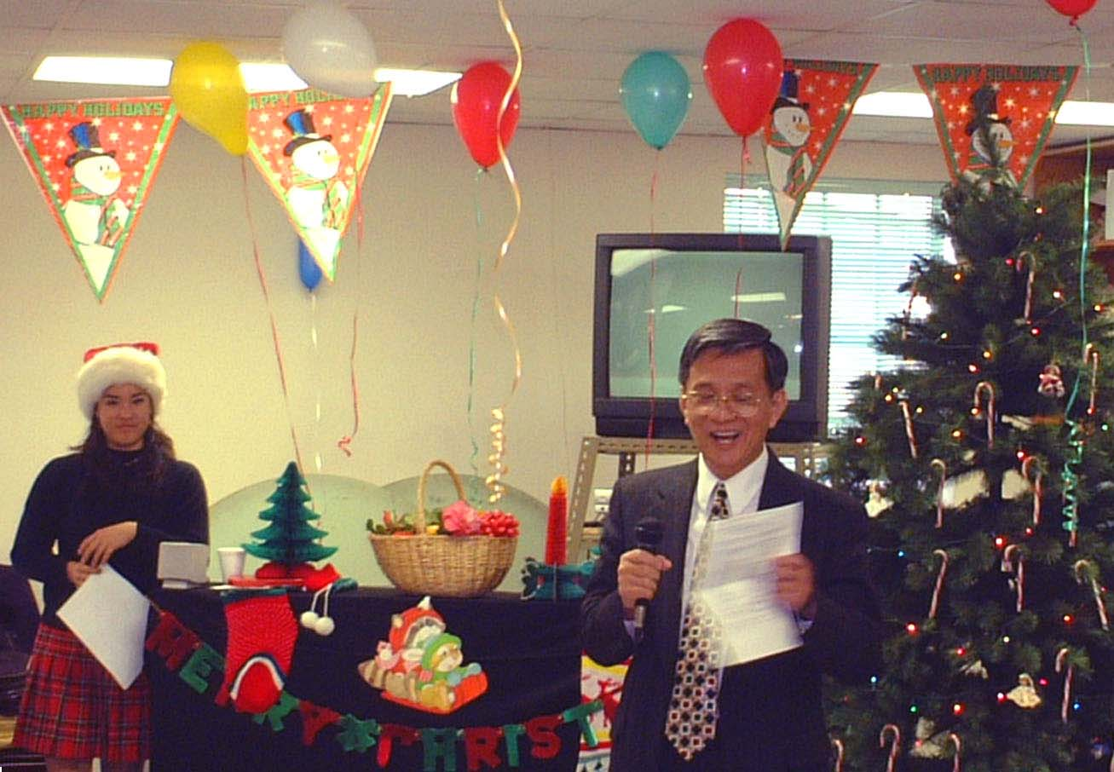

Today we want to say thanks to our leaders: Elder Han, Senior Chen, and the transmitting masters and lecturers for the arrangements of English Tao Class in the year 2002. They are working so hard. At this moment, I would like to share this with everybody: “As a candle gives out light, it must endure burning.” Our Holly Teacher lights our mind, which lights our heart, so the following steps will be cultivating ourselves and propagating Tao to others.

s



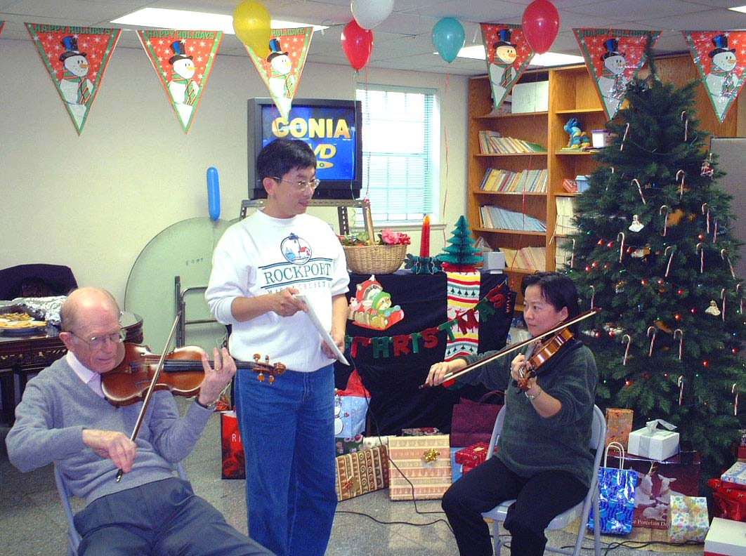

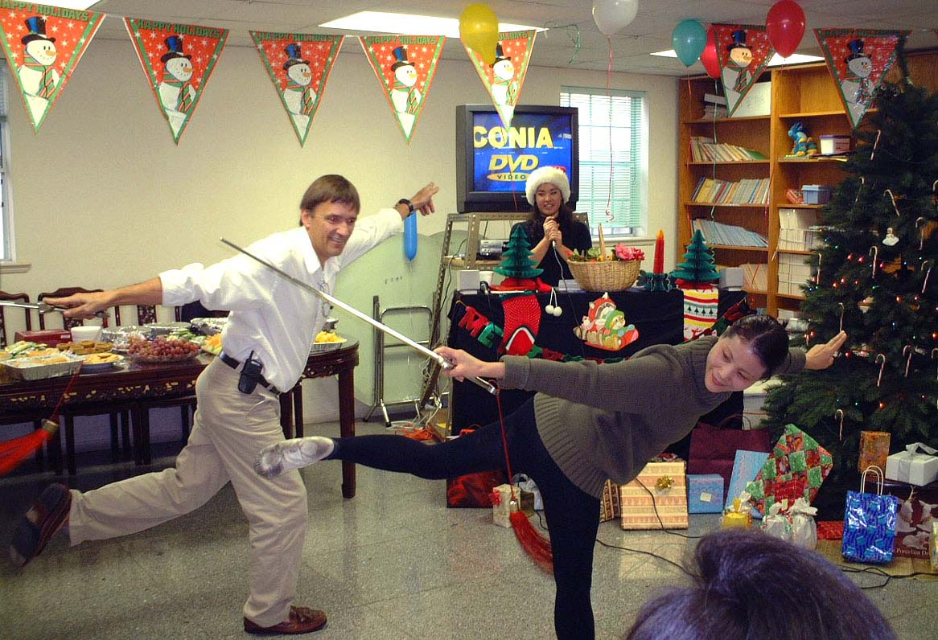

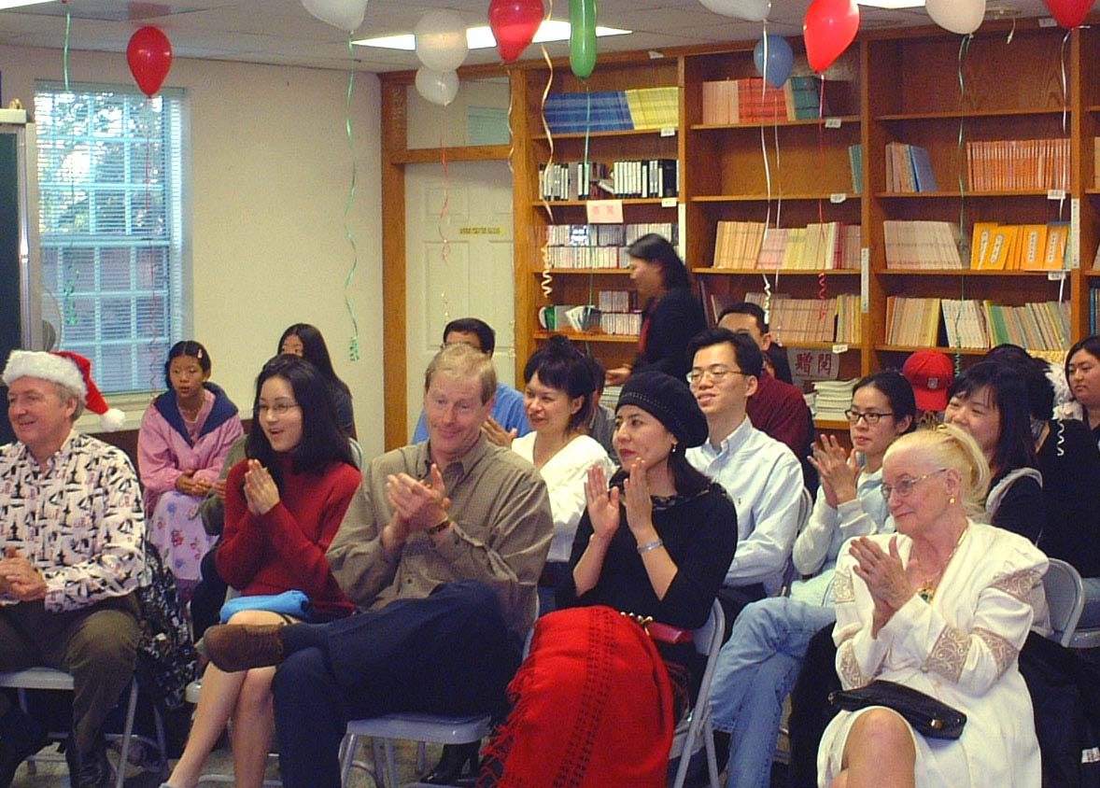

Finally, I hope you would continuously attend English Tao Class next year. I also wish all of you a happy holiday. It’s probably a little bit early, but it’s my only chance to say that to you guys. Merry Christmas and Happy New Year! God bless everybody. And help yourself and enjoy the party. Thank you!

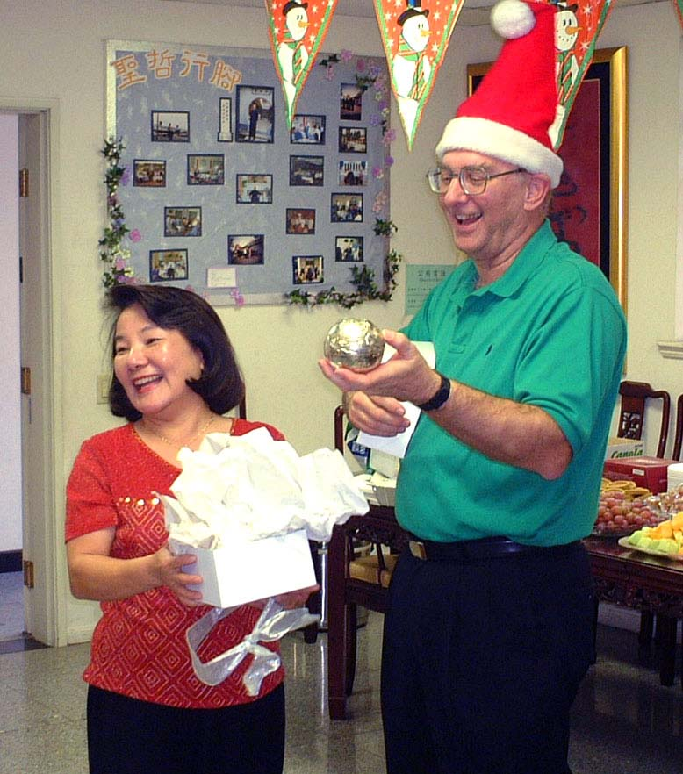

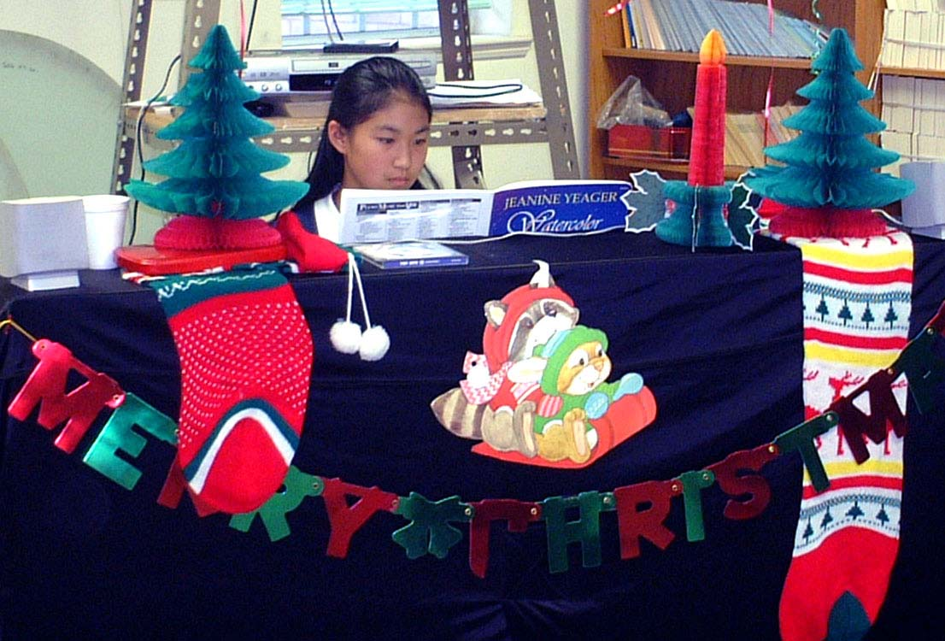

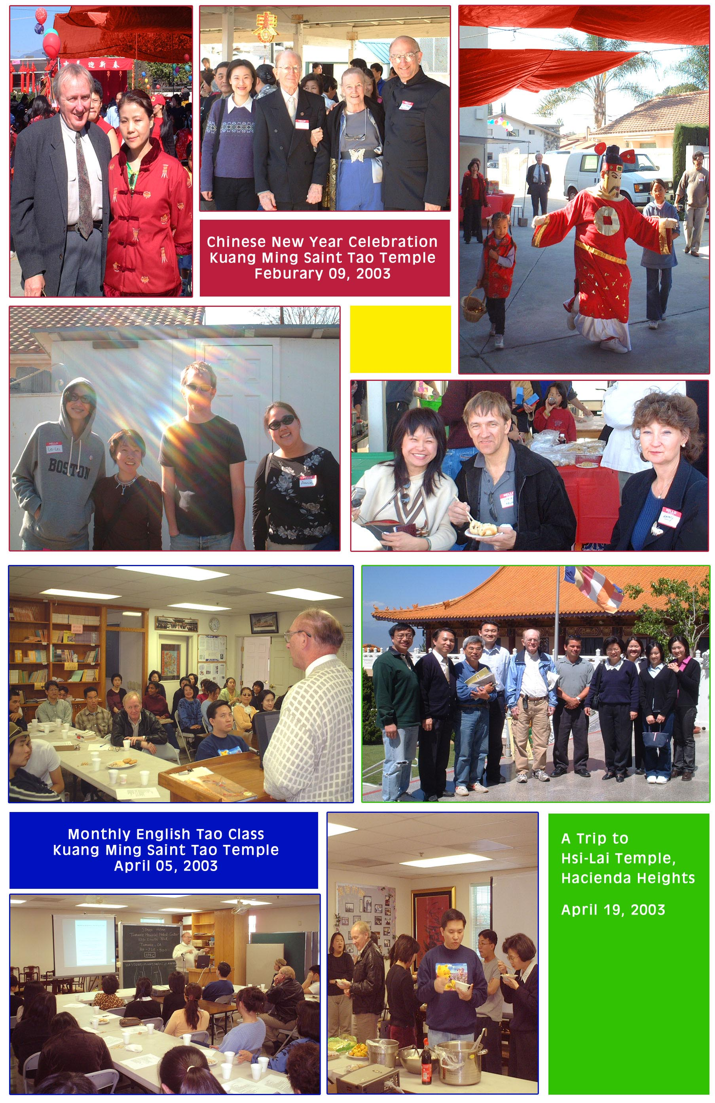


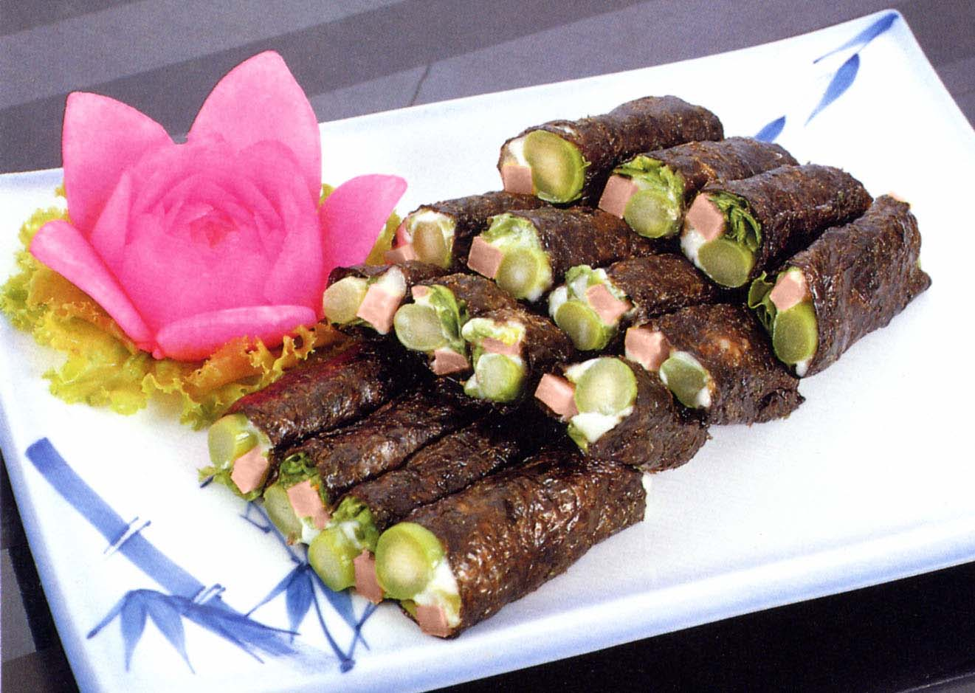

- Cut the vegetarian ham into long slices.
- Gently fry the vegetarian ham.
- Place a portion of asparagus, a portion of vegetarian ham, some shredded lettuce and some of (1) on a sheet of purple laver and top with a bit of mayonnaise.
- Roll it into a cylindrical shape and cut into 4 equal pieces.

Fresh Asparagus 150 g (1/3lb.)
Vegetarian Ham 50g (1 ¾ oz.)
Shredded Lettuce 50g (1 ¾ oz.)
Purple Laver 3 sheets
Mayonnaise 4 T.
(1)
Peanut powder 1 t.
Sugar 1 t.

T. = Tablespoon
t. = Teaspoon

- Cut each sheet of purple laver in half to make a total 6 sheets.
- Blanch the asparagus briefly in boiling water, cool in cold water, then peel.
- Cut the asparagus into the same length as the laver.

A Vegetarian's Kitchen

Get Involved!!
Share your insightful thoughts or valuable pictures with other Tao members. Here are few suggestions:
Life after receiving Tao
Personal experience of how to propagate Tao to others
Tao in daily life
Personal thoughts about life
Temple activities (e.g., Christmas party)
Your secret vegetarian (i.e., no meat, seafood, garlic, onion, green onion
and leek) recipe  Please provide me a photo of your dish.
(By submitting your article and/or picture to us, your permission is given for future editing of your essay and/or picture. Essays should not exceed 800 words due to the limited space.)

Message Board
Survey
Your opinions are valuable to us. Please take a minute to answer the following questions:
What’s your favorite section in this issue?
Why?
What’s your least favorite section? Why?
Does the name of this newsletter (Station of Soul)
mean anything to you? Your Reasons?
How do you like the layout of this issue?
What can we do to improve?
Any other suggestion?
Please send your responses to Angel Huang (SuikaShen@aol.com). ‘Til next time!

