Kuang Ming Saint Tao Temple

Issue 3 November 2002

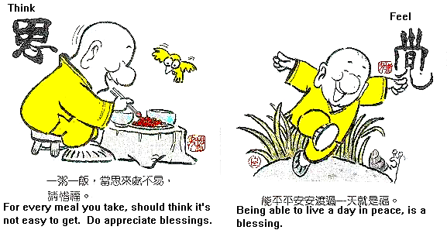
Think  Do consider that a drop of porridge and a grain of rice do not come easily. Please treasure the blessings. | Awareness  It is a blessing itself being able to live a day in peace.

From the Editor:
Thanks to the grace of Heaven and the virtue of the Masters, the new issue of SOS is finally here! Towards the end of the editing phase, I suddenly experienced some technical problems with the file. I’m happy and relieved that this issue of SOS could be delivered to you on time!
In addition, if you have any thought or experience that you would like to share with us, don’t be shy!! For more information, please contact Angel Huang (SuikaShen@aol.com). This e-mail address is for anything that is SOS-related and will be checked once a week.
It’s time to enjoy this brand-new issue of SOS!
Inside

Explanations of The Answers to the Truth
       3

Journey—
Voyage to China 2002: Some Reflections
       5

Activities----
A Native English Speaker’s Perspective
      7

Activities----
Cross Culture Exchange Meeting – A Trip to Irvine Senior Center
      9

A Vegetarian’s Kitchen
      11

Message Board
      12

Issue 3 November 2002

Kuang Ming Saint Tao Temple

11139 E. Lower Azusa Rd.
El Monte, CA 91731
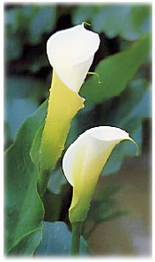

Explanations of *

Holy Teacher, Ji-Gong Living Buddha

What is the difference between the Tao of Heaven and the Tao of Mankind? Which one should be practiced first?

One who emphasizes his practice of Tao on his True Self and his life, and takes on the mission of bringing salvation to the world is the one who follows the Tao of Heaven. One who emphasizes on ethics, morality, and five virtues of Tao is one who follows the Tao of Mankind. The Tao of Mankind is the basis of the Tao of Heaven. Thus, whoever practices Tao should start with the Tao of Mankind.

Filial devotion, brotherly love, loyalty, trustworthiness, propriety, righteousness, integrity, and feeling shame are the eight most important attributes of one's character. God constantly evaluates people's hearts and observes people's actions. For those who do not respect their parents, do not love their brothers and sisters, work and act perfunctorily, do not keep their promises, have no propriety, have no justice, have no integrity, or have no shame, their practices will not benefit them. If one does not behave according to the Tao of Mankind, how can he follow the Tao of Heaven? Thus, to practice Tao, one must fulfill the Tao of Mankind first. Confucius said: "By learning the Tao of
Mankind, a practitioner of Tao** can extend it to the Tao of Heaven." Thus, when one perfects the Tao of Mankind, he is not far from the Tao of Heaven.

The practice of Tao is endless. Is there any easy method for a beginner to follow step by step?

Confucian practice of Tao is holding the heart to cultivate the True Self. A beginner in practicing Tao needs only to follow this method. Rewards will be awarded when one keeps goodness in his heart. Punishments will be instituted when one keeps evil in his heart. Longevity can be attained by keeping tranquility in one’s heart. Thus, one must constantly adhere his mind to his

Right Protal*** . This is what the saying--“A practitioner of Tao constantly keeps himself at the center”--meant. By constantly adhering one’s mind to his Right Portal, he is holding his heart to cultivate his True Self.

Mencius said: “A practitioner of Tao differs from the common by keeping the five virtues of Tao…. Some keep benevolence in their conscience. Some keep propriety in their conscience…. The benevolent loves others. The wise benefits others. The decorous respects others…. One who loves others will be loved. One who respects others will be respected.” As practitioners of Tao, in addition to the five virtues of Tao, we should constantly keep the True Nature in our mind, and this will be sufficient. 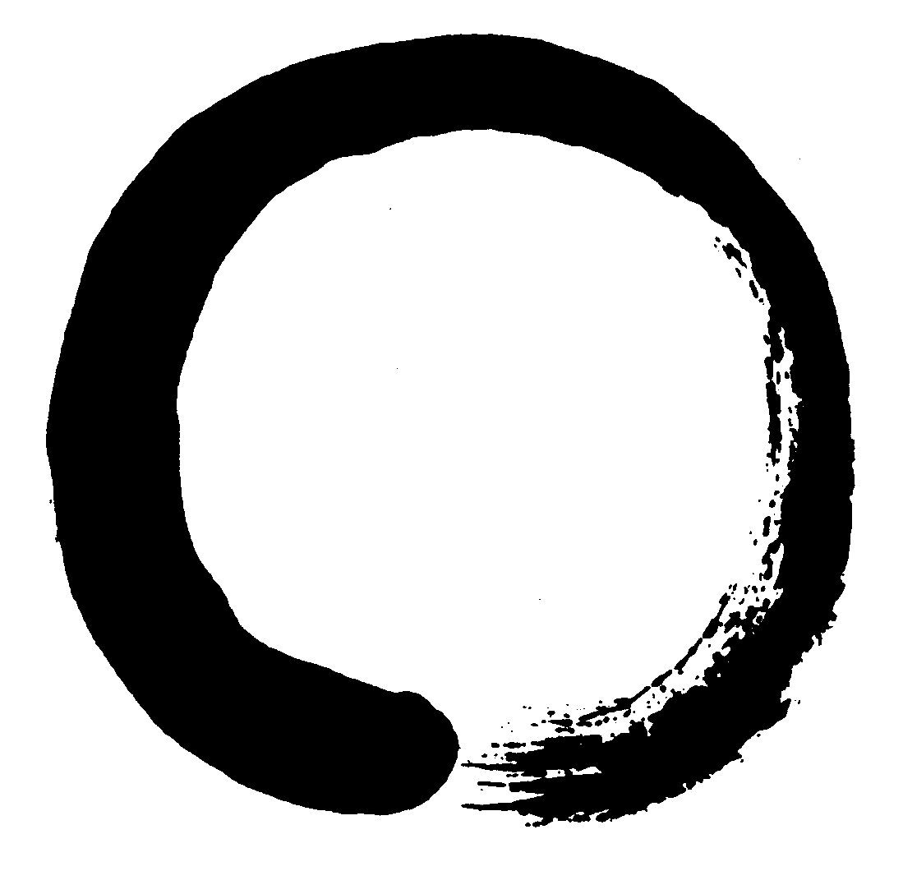
Notes from the Editor
* The above Q and A’s are taken from the book, Explanations of The Answers to the Truth (Xing Li Ti Shi). The original Chinese version is by Holy Teacher, Ji-Gong Living Buddha. It contains 90 Q and A’s. The English version is translated by the translators at Zhong-Hua Public Temple.
** Tao cultivator is referred as practitioner of Tao in this book.
*** In this book, the Heavenly Portal (the Portal or the Gate) is referred as the Right Portal.

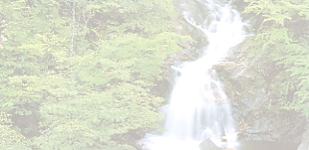

Everybody will die, but there is a long
road to get by
Proceed and make your life bright
You need to make up your mind
Best choice for your life is to lead the
Tao life
Tao is always by your side, go on and
insist in this line
Clean your heart at this Holy time
This is the place you must purify
‘Cause everybody has just one life
And when you do, it makes fine

By Holy Teacher

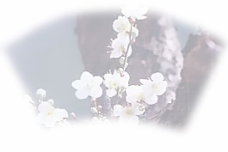
Some Reflections
Thomas E. Maher
I had been there before. Once. The occasion was a research study of international joint ventures in China on behalf of three universities. It brought two of my colleagues and me to Shanghai, Nanjing and Wuhu in 2000. But it was only a week, all told, and we were working most of the time with little opportunity to experience the culture and the people. Everything was carefully translated into English in a sterile environment and, beyond its purely academic objectives, only teased one’s imagination of the China that lay enticingly nearby.
With my aspirations of many years unfulfilled, I wondered whether I would ever have a chance to encounter first hand this land of antiquity, of past glory, of dynasties, of revolution, of warlords, of foreign conquest and defeat, of strange customs and language, of vast expanse and immense population? Of emperors and empresses, eunuchs and concubines? The land of which Marco Polo spoke of in such intriguing terms? The land which gave birth to the silk road? The land in which Mahayana Buddhism once flourished after its importation by Bodhidharma from India? The land of Lao Tzu and Confucius? The land of some of the world’s most beautiful poetry but one utterly devastated by a “cultural revolution?” The land, today, of a different political persuasion than my own and of decreasing but still extensive poverty? The land, today, of vast construction and improvement according to widely published reports?
I had pretty well relegated my aspirations to the junk heap of dreams unrealized and unlikely to be fulfilled during my dwindling years on earth. I would have to content myself with my travels throughout Southeast Asia on various occasions as a military officer in the late 1960s and early 1970s. My mindset of a China under Mao Tse-Tung, ringed by a bamboo curtain that forbade free access to the outside world, did not give way easily to events that were gradually and significantly changing things. Like others, I had not sufficiently grasped the implications of Deng Xiao-Ping’s “Open Door Policy” of the late 1970s, an event which was unfolding before my very eyes had they been open to see. His mixture of a centrally controlled government and a free market economy still seemed to most academicians as inherently and fundamentally contradictory and unlikely to succeed. And his notorious utterance, “It matters not whether the cat is black or white, but only whether it catches the rat,” seemed not much more than the hyperbole and bluster of the relentlessly undaunted.
Things changed abruptly in the summer of 2002. Thanks to a chance introduction to Tracy, a fellow member of the I-Kuan Tao (pronounced as Yi Guan Dao), a trip to China in the very near future seemed not only possible but economically feasible. In fact, it seemed that I

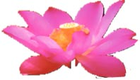
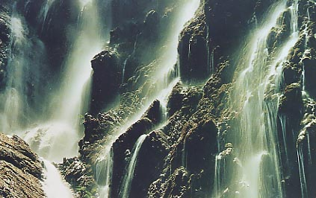
might be able to bring my wife, Kathleen, along despite her handicapped condition. I was encouraged enough to set things in motion, although with rather weak determination at the outset, thinking that the trip was unlikely to materialize for one reason or another. But gradually it became an obsession that was to be achieved no matter what, and, on September 20, 2002, we set out

from Los Angeles on a twelve-day sojourn in China that was to exceed our expectations by a margin too wide to describe. Our trip took us to Beijing, Xian, Shanghai, Guilin, Guangzhou and Hong Kong.
We landed in Beijing in the late afternoon of September 21, where our well-informed and congenial guide was on hand to greet us and form our group of 24 people from different points of origin. All were of Chinese ancestry except one couple of Japanese ancestry. All, of course, were residents of the U.S. or Canada. We were the only Caucasians. I was immediately surprised by the fact that we proceeded through Chinese immigration almost without stopping. Customs didn’t even look at our luggage.
I can tell you, first off, that the Confucian ethic of filial piety and respect for the elder (one of the five Cardinal Relations) is alive and well. We fully expected to fend for ourselves, but our fellow travelers and newly found friends set out immediately to help us at every turn, assisting Kathleen on and off buses and up and down stairs and to rest rooms, tying our shoe laces, refusing to let us carry our baggage, making sure we were seated at dinner tables and that visits to various attractions were not too fast for us, etc. They left nothing unattended. It almost seemed that this was the primary purpose of their trip!
I climbed to the second station of the Great Wall, a portion of which seemed almost vertical. It is as high as you can go because the wall is fenced off at that point. I was accompanied by several of our young friends, who climbed before and after me to make sure, I guess, that I didn’t suddenly fall backward on the way up or lunge forward on the way down. They apparently spread the word that I was 81 years old because several strangers making the same climb asked me if that were really true. Of course, Kathleen didn’t make the climb but waited at the bottom to insist that I buy a T-shirt when I returned, reading, “I climbed the Great Wall.” Our guide had previously informed us that those who reached the second station would be regarded as “heroes.” But our guide didn’t go! Few climbers went that high!
Well, Angel has informed me that I shouldn’t exceed 1000 words, and I’m rapidly approaching that point. Suffice it to say that in Beijing we also toured the Forbidden City and Tiananmen Square (Gate of Heavenly Peace), both of which were much larger than I had thought. As I faced the Square, I glanced at the Great Hall of the People on my right. I recalled that I had mentioned that building by name in an article I had published a few years earlier, in which I had referred to Jiang Zemin’s declaration that he was eliminating 300,000 of China’s state owned enterprises (SOEs). While in Beijing, we also visited the Temple of Heaven, an edifice of great antiquity and cultural importance, the Ming tombs, and the Summer Palace.
We were amazed at the beauty of Beijing, with its tall, artistically architectured buildings and its wide, well designed boulevards. (To be continued)

A Native English Speaker's

Steve Halme
During a dinner not so long ago I was asked a very good question by a friend who does not study Tao. He wanted to know what I've learned from Tao, and what effect it has had on my life given that English class is held but once a month. Without delay I responded with two factors that have provided a positive influence on my everyday thoughts, even on the way in which I live my life. They are my Tao relatives and the Tao temple.
The first impression I had of I-Kuan Tao was of the Kuang Ming Saint Tao Temple members. They are a varied group ranging from young-to-old and from quiet-to-talkative, but they share one common trait: Goodness. The atmosphere of peace and understanding that they engender impressed me on my very first visit, and is a major reason why I return to the temple again and again. Each class provides a boost of positive energy needed by my body and has been a factor in calming my mind and allowing me to become an even better man. My Tao family is as fine a group of men and women as I've ever been associated with, and I thank them all for accepting me into the temple and for beginning to teach me the ways of Tao.
Even though I still have much to learn, I find that Tao has managed to work magic on my soul. How has this occurred? The very people I have just mentioned are not only friends, but teachers. Many of them give of their time and energy to write and lecture to the class regularly. The topics are enlightening and simple in nature, yet with meaning to be considered beyond the classroom. People in today's hectic world rarely take the time to consider such topics and they miss the benefits of doing so. I find encouragement not only in the message delivered but in the passion of the lecturers themselves. This was no more evident to me than during the Tao Seminar held in Kuang Ming Saint Tao Temple on July 13 and 14. An entire two-day’s

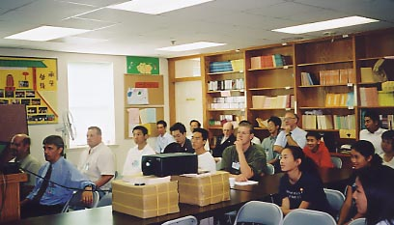

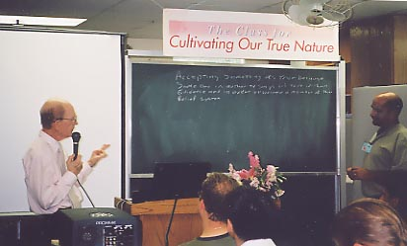

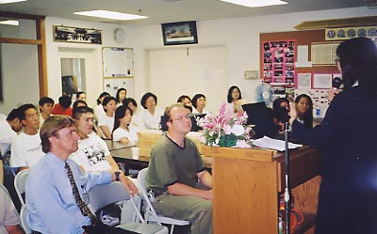

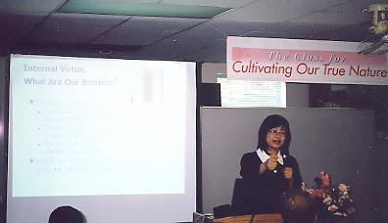

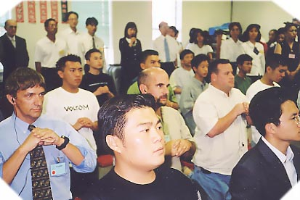
worth of lectures were written and assembled in a very professional manner by the Tao members. In my own profession I have written lectures and taught hundreds of people, and so I know what level of effort is required by both the individual and the organization. The July Seminar was truly memorable and I applaud those involved.

In fact it was the quality of the Tao Seminar, which allowed me to have the remarkable experience of seeing, first hand, the appearance of Buddha! Because of the excellent Chinese-to-English translations we English speakers were provided, we were able to partake in this miracle as well. How can this not help to transform a one-time Lutheran into a believer of Tao? I even had the honor of personally telling Buddha “xièxie” when I was given fruit!
A third major influence on my ability to understand Tao is a special friend of mine, another Tao member. Chinese is her first language and thus she understands the nuances and inner meanings of her Tao lessons better. Since she also speaks excellent English, she is able to share her translations, her ideas and culture with me. This has essentially extended my learning to outside of the Temple and has helped tremendously.
To have such a friend is invaluable when class time is limited, as is the case with the English Tao Classes. I heartily encourage all English speaking members to discuss Tao with their Chinese Tao friends outside of the temple.
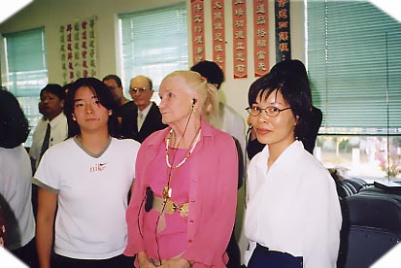
Finally, I’m sure that I can speak for the rest of the English Tao Class in offing thanks to all those who take time to share Tao both inside of and outside of the Temple. It is often difficult for the English-speaking members, especially Caucasians, to understand the finer points of Chinese philosophy. You make a better understanding possible and for that we are greatly appreciative. Xièxie!

Thanks to the grace of Heaven and the virtue of the Masters, the English Tao Seminar (ETS) at the Kuang Ming Saint Tao Temple on July 13-14, 2002 was successfully held. There were twelve class members graduated from this ETS, ten gentlemen and two ladies. Let’s all congratulate them and welcome them to continue their journey in Tao with us!

Cross Culture Exchange Meeting

Walter Weng
The idea of this trip came to my mind when the Chinese language and culture class which I* volunteered as instructor was about to come to an end around mid April. After some basic daily Chinese oral phrases and philosophy had been introduced, the seniors were eager to know more about Chinese philosophy. Then I thought it probably would not be a bad idea if we could invite our English Tao members to pay a visit on these seniors and to help them apprehend the true meaning of Tao in different ways.
Thanks to Lecturer Peter Peng’s and Lecturer Arnold Wang’s firm support. We also got a very enthusiastic response from the supervisor of Irvine Senior Center, Carol Green. She not only agreed this activity but also proposed a wonderful title for the meeting: Cross Culture Exchange Meeting. Lecturer Peter Peng and I liked that title as well. Through several back and forth e-mail discussions, Irvine Senior Center (abbreviated as ISC) generously agreed to provide the facilities, tea and coffee; our English Tao Class (abbreviated as ETC) was responsible for the foods and others.
The meeting was held on Saturday April 13, 2002 at Irvine Senior Center from noon to 3:30 p.m. Twenty-three people attended (14 from ETC, 9 from ISC). It was a potluck type. Lecturer Bonny Yu’s veggie restaurant & Lecturer Tsai’s new nature veggie foods store supported us with several dishes. Totally we had some over ten various dishes plus desserts and fruits. The meeting started late at around 12:20 p.m. because some ETC members were trapped in the car crowds on I-5 freeway. Najma Quader, former president of Irvine Multicultural Association made a welcoming speech on behalf of ISC. Lecturer Arnold Wang acted on behalf of ETC to give a brief speech too. Then the potluck

* In Lecturer Walter Weng’s original writing, the term “hou xue” is used in places of “I.” “Hou xue” is a temple term referring to oneself in humbleness.

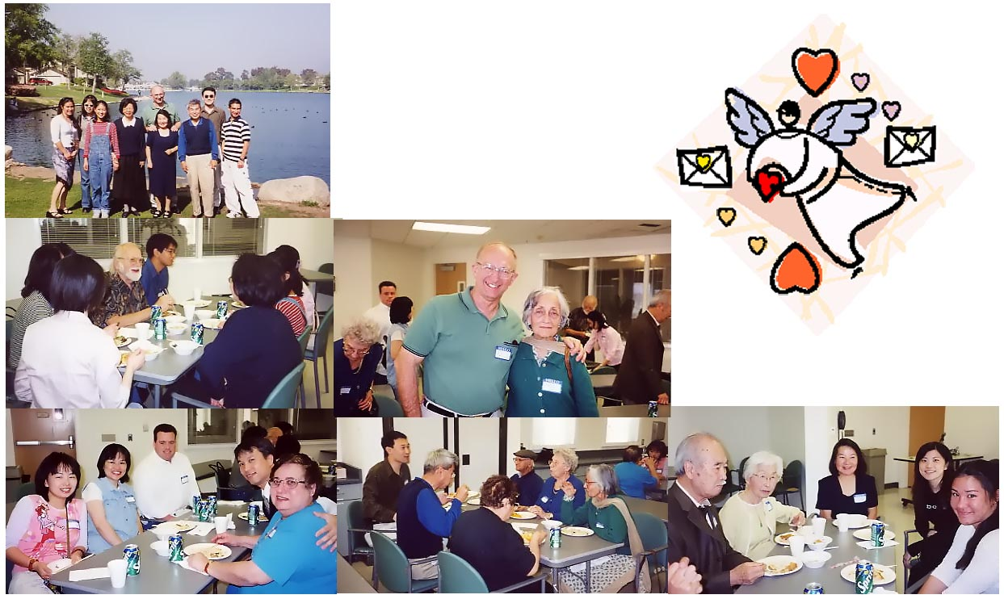
lunch began. Boy, the seniors really loved and enjoyed the yummy vegetarian dishes a lot. While having lunch, we purposely divided into several small groups so each senior could be well taken care of. The seniors originally came from various places in the world: the U.S., Sri Lanka, Korea, India and Sweden.
During the sharing session after lunch, each senior shared his/her secret why s/he came to this class and how enjoyable s/he was and etc. There was a Korean couple who are both retired professors from Chicago and moved to Irvine two years ago. I did not know about their background until they introduced themselves during the sharing. Personally, I admire them for their enthusiasm in learning. The husband said he is also promoting the reunion of North and South Korea. The atmosphere and the mood of the sharing were warm and lasted for almost hour and half. Najma Quader, former president of Irvine Multicultural Association, even proposed to us to visit them once every quarter.
The meeting was adjourned at 3:30 p.m. Some of the ETC members went to a beautiful man-made lake that was just few minutes away from ISC to enjoy a walk around the lake under the warm spring sunshine afterwards.
To try to propagate Tao starts from creating friendship with the communities. Does this correspond with one of Lao Tzu’s sayings: “A journey of a thousand miles starts under one’s feet?”
A true Tao cultivator should focus on cultivating himself/herself at the beginning stage first. After some period of time, s/he then should put it into practice to help others to know the truth based on the faith s/he has already had. It is because we have an unselfish mind that wants to share the best we have within.

- Blend tofu, corn cream, water and spices for 5 minutes
- Add corn powder to the blended mixture
- Stir-fry shitake mushroom
- Spray some vegetable oil onto a container
- Pour mixture into the container
- Put mushroom, carrot and green peas on top
- Steam it with high heat until the water is boiled
- Switch to low heat and steam it for 10 more minutes

Soft Tofu 1 piece
Corn (cream style) ½ can
Shitake Mushroom 3 pieces
Carrot (boiled) 3 pieces
Baby Green Pea A little
Corn Powder 1 T.
Water ½ Cup

Spices
Vegetable Oil 2 T.
Salt ¼ t.
Rock Sugar ¼ t.

T. = Tablespoon
t. = Teaspoon

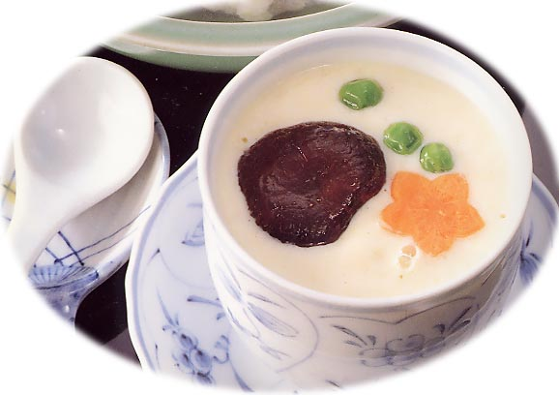
A Vegetarian's Kitchen
Message Board
Don’t forget this year’s Christmas party! It’ll be held at 2:30 pm on December 7. Various fun activities are planned for this year’s party, so don’t miss it. See you there!
Share your valuable thoughts or personal experience with other Tao members! The followings are few suggestions (essays should not exceed 800 words due to the limited space):
Life after receiving Tao
Personal experience of how to propagate Tao to others
Tao in daily life
Personal thoughts about life
Temple activities (e.g., Christmas party)
Your secret vegetarian (i.e., no meat, seafood, garlic,
onion, green onion and leek) recipe  Please provide me
a photo of your dish
Please help me improve this newsletter.
All suggestions are welcome and greatly appreciated!!
For anything that is SOS-related, please contact Angel Huang (SuikaShen@aol.com). Thank you very much!! ‘Til next time!

